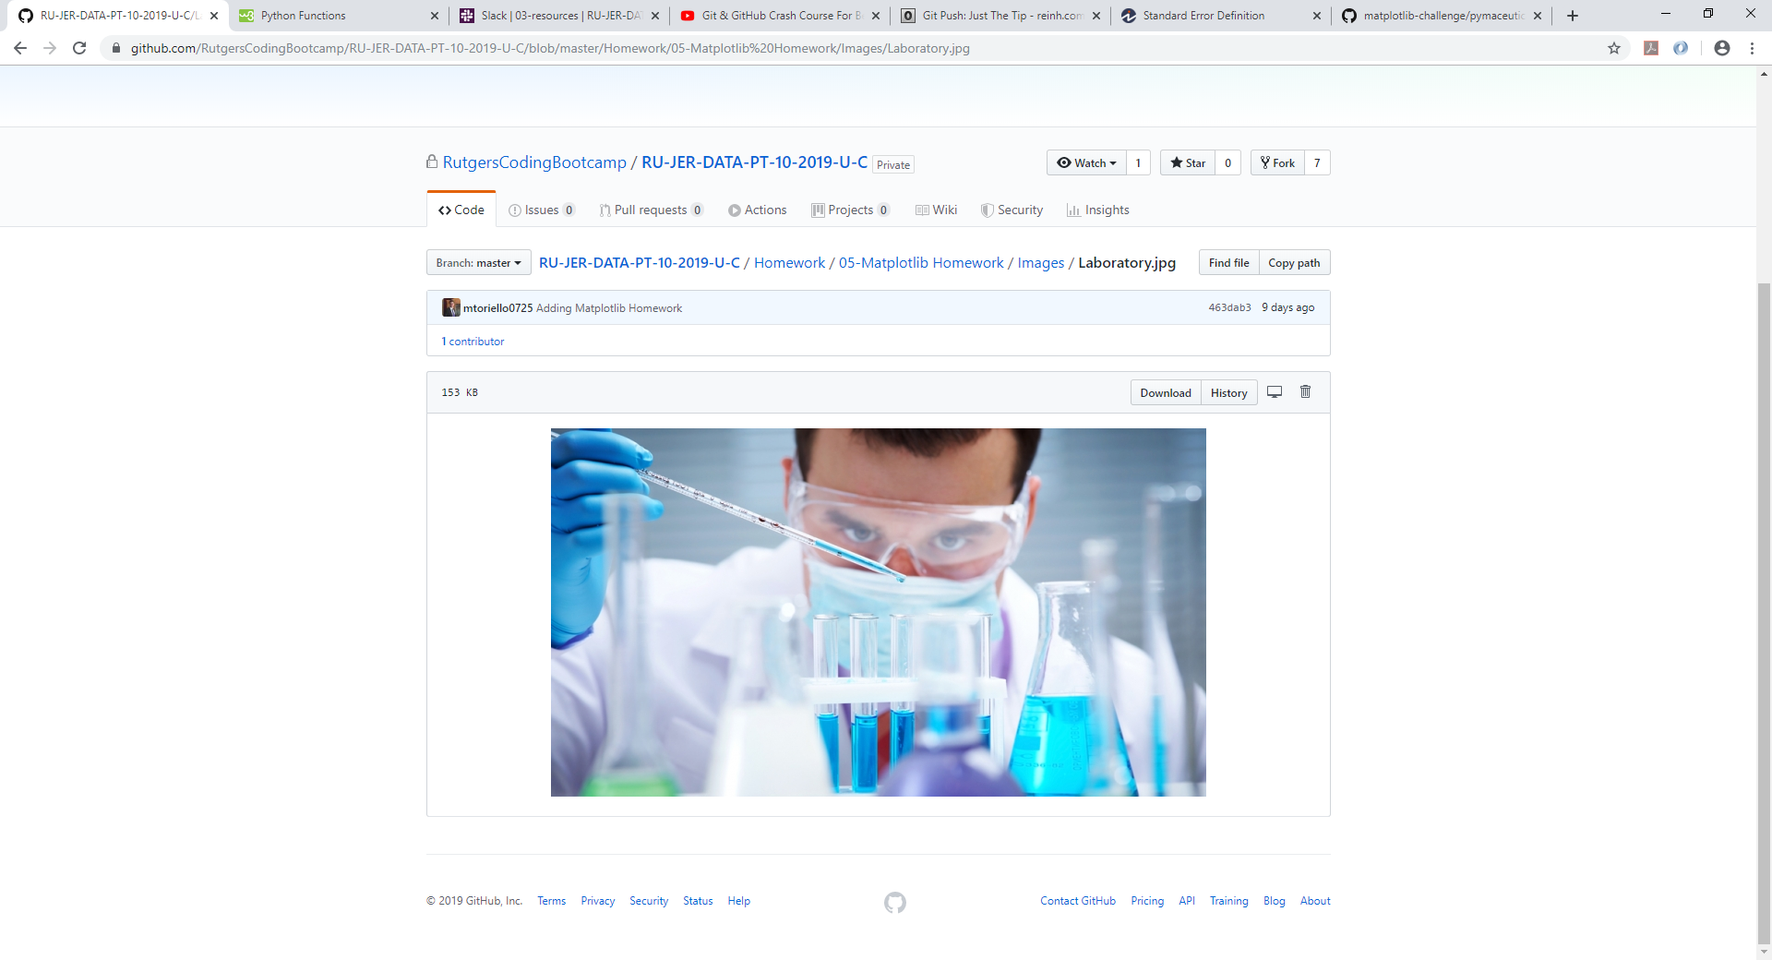

The Power of Plots

Matplotlib

Jeffrey Kim | Rutgers Data Science Bootcamp | 11/24/2019

This study has analyzed the treatments of Capomulin, Infubinol, and Ketapril along with Placebo for a comparison for treatment over the course of 45 days. We have successfully monitored their physiological responses and came up with the following results.

Capomulin was the only treatment that we deemed to be successful in reducing the size of the tumor over the course of 45 days. Capomulin has also had the least amount of metastatic spread during this time and resulted in the strongest percentage of survival rate during the period of treatment. To begin our analysis, the chart below will depict the metastatic spread during the time of treatment.

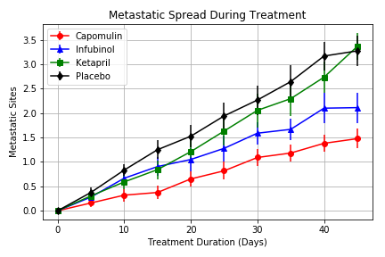

As you can see Capomulin led the way in the least amount of metastatic spread during this period. Ketapril was the least effective as it yielded similarly with the placebo results. Capomulin yielded a metastatic spread of 1.5 at the end of the 45 day period. If you look closely at the chart, you will see that the standard of error for Capomulin was also the least amount compared to the other comparisons which depicts that most accurate reading from our sample collection of data.

From the chart below, you can also find that the survival rate during the period of treatment was more than double the rate of the other treatments. Capomulin led to 84% survival rate within the period of 45 days of treatment. The next closest treatment was from our selection was Ketapril which was at 44% survival rate.

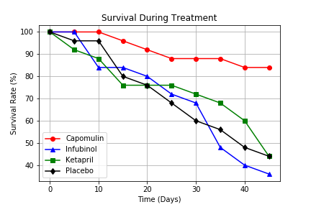

The next chart below will also show that Capomulin was the only treatment that reduced the size of the tumor over the 45 days of treatement. From our data collected, the tumor in response to the treatment reduced in size from 45 mm3 to 35 mm3. The other 2 teatments along with placebo were very similar in result with an increase in the size of the tumor.

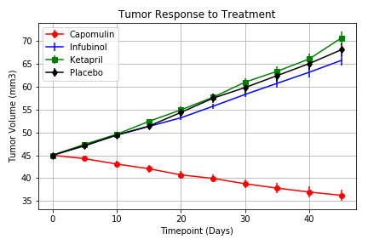

The last chart that we would like to depict will support our analysis with the previous graph by displaying a percent change of a 19% decrease in size of the tumor within the 45 days of treatment.

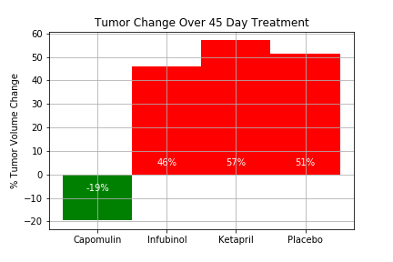

From our sample data collected, it can be concluded that Capomulin was the best treatment available out of the 3 treatments selected.